Project Report Template

1.INTRODUCTION

1.1.Overview

Indian record label T-Series is the most-subscribed channel, with over 250 million subscribers as of October 2023. American YouTube personality MrBeast is the most-subscribed individual and second most-subscribed channel overall, with 194 million subscribers as of October 2023.

Indian record label [T-Series](https://en.wikipedia.org/wiki/T-Series_(company)) is the most-subscribed channel, with over 250 million subscribers as of October 2023.

Since its launch in 2005, YouTube has been the go-to platform for entertainment. Whether you're in the mood for funny moments, news updates, or educational content, YouTube has it all. Regarding capturing viewers' interest, some YouTube channels have stood out and secured a spot in the world's top 10 most subscribed YouTube channels. In this article, we find out all about these most subscribed channels on YouTube.

The great thing about YouTube is that there’s a channel for everyone, whether you’re looking to learn quick science facts or how to use your new gaming controller.

Have you ever wondered which YouTube channel holds the title of being the most followed in the world? Well, the answer might surprise you.

Believe it or not, the most followed YouTube channel hails from India. With its captivating Bollywood songs and snippets, T-Series claims the top spot among the top 10 YouTube channels with the most subscribers **(as of September 04, 2023)**

1.1.Purpose

Uses:

Starting a YouTube channel gives your audience access to more of your content. If you already use video marketing in your marketing strategy, a YouTube channel gives you a centralized location to post advertisements, informational content and entertainment videos.

A nice side effect of adding the extra content is that it drives more traffic. People can now find you on YouTube and on your site. Right now, we still drive more traffic from our site to the YouTube channel than the other way around, but we are starting to see some come the other way. In the beginning, if you only have a food blog, this will probably be your results as well.

2.Problem Definition & Design Thinking

2.1. Empathy map

An empathy map is a system to outline which imagines what a designer thinks about a specific user.Visualizing a user's behavior in an empathy map helps UX teams or designers align on a deep understanding of end-users. The process draws out the information everyone has about the user to arrive at a common understanding.

Themes guide an individual to focus on the key areas that need attention.With theming, you can look at major user problems and notice how they might map your user journey.Once you have the quadrant's data, remember to divide them into categories. Now,you need to work through one section at a time and find themes.

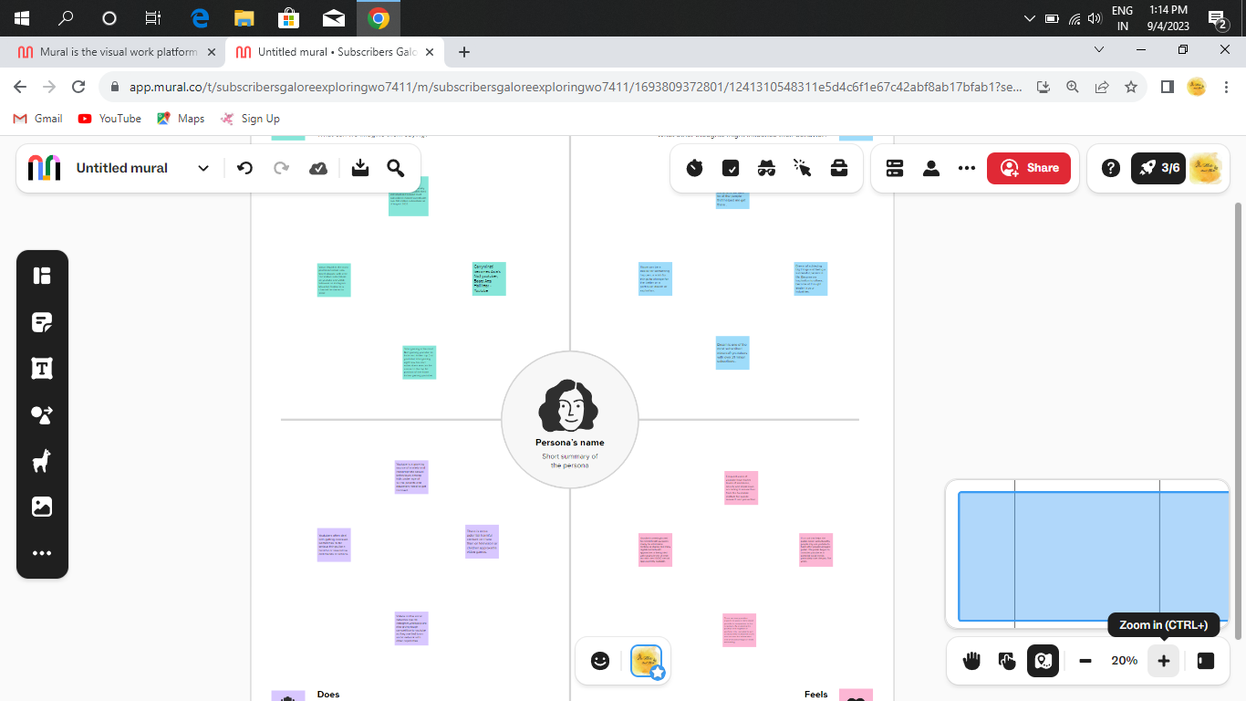

2.2. Ideation & Brainstorming map

A mind map is a great tool for brainstorming new ideas. Its unstructured format allows ideas and thoughts to flow freely. Since concepts are placed in groupings, it also allows ideas to jump around among topics, rather than forcing them down a list.

Brainstorming is also known as clustering because ideas are broken down and clustered together.

Brainstorming allows students to think critically about ideas and solutions, form connections, and share ideas with peers. Often, there are no wrong answers when brainstorming; in this way, students are able to freely express their thoughts without fear of failure.

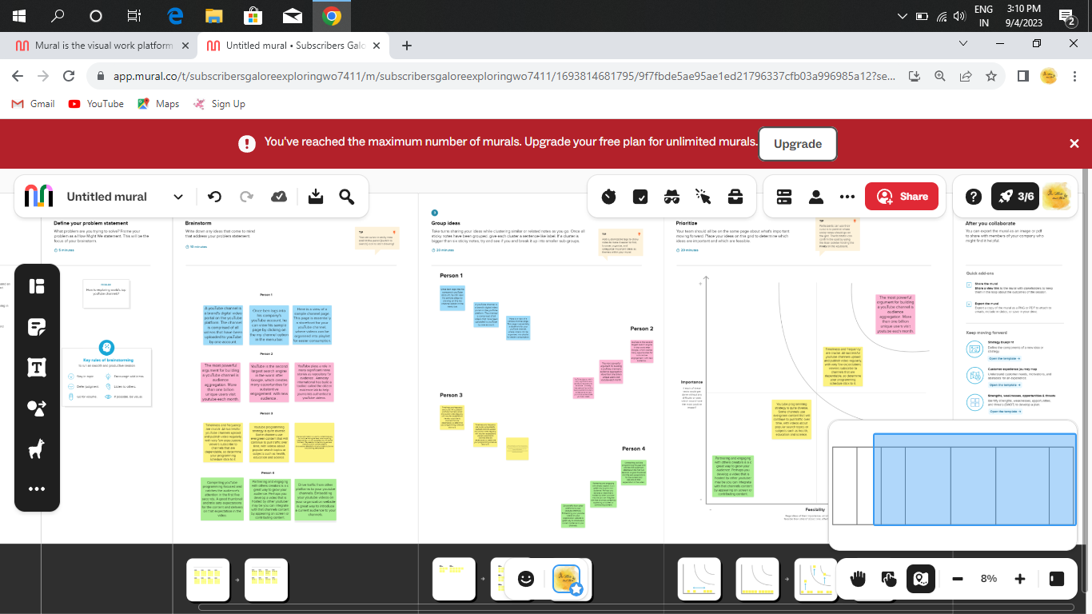

3. RESULT

Growing your subscriber base is essential in increasing your revenue potential on YouTube. Scalefluence provides the perfect platform to make your dreams a reality. With powerful algorithmic pricing, you can now get paid for what you love doing! No more worrying about how much you will be compensated or when – [sign up today](https://app.scalefluence.com/#/signUp) and start connecting with leading brands that are eager to collaborate with you.

If a YouTuber has at least 1 million subscribers, they can make an **average annual salary of $60,000**. They can also earn $2,000-$3,000 for a video that gets 1 million views. The average YouTuber typically earns $18 for every 1,000 ad views, which means that they can make $600-$1,000 per week for an audience of 100,000 subscribers. Ad viewership is the primary source of revenue for YouTube creators, but there are other revenue streams available, such as sponsorships, merchandise sales, and affiliate marketing.

4. Advantages and Disadvantages :

Advantages:

Uploading and watching videos on YouTube is completely free. This gives you the opportunity to experiment and find out whether it works for you or not without worrying about the costs.

With YouTube, you can earn money for your views. To earn money through your videos, you will have to have a Google AdSense account. Don’t have a Google AdSense account? You are able to create a new Google AdSense account with your YouTube channels.

YouTube is easy to use for everyone, even if you don’t have any computer skills. Still, don’t know how to use this social media platform? Don’t worry, there are many tutorials out there to show you how to upload a video and much more.

Disadavantages:

YouTube is a public social media platform. This means people don’t need to create an account to see any of your videos you publish on your channels. Also, anyone can post a video. This can cause copyright issues, and there could be issues with privacy invasion.

Like any other social media platform, YouTube has many rules which restrict what you can do within your channel. This can be through terms of optimisation, what things you can post on your channel and how your channel looks.

This means that even your competitors can run an add on or near your video, which can hurt your brand.

There are many more advantages and disadvantages of YouTube, but these are the ones we think you should know about. It depends on your norms and values which advantage or disadvantage weighs the most for you. Of course, there is nothing wrong with trying out something new. Otherwise, you will never know whether it’s something for you!

5. Application:

YouTube, the Google-owned video network, boasts [over two billion monthly users](https://www.youtube.com/yt/press/statistics.html?ref=buffer.com) — nearly half of all people on the Internet — and every day, people watch hundreds of millions of hours on [YouTube](http://youtube.com/?ref=buffer.com) and generate billions of views.

What’s more amazing is that [92% of Internet users](https://www.hootsuite.com/en-gb/resources/digital-trends?ref=buffer.com) watch some form of video content every day. So, there's no reason your business shouldn't be investing in YouTube as part of your [social media strategy](http://www.skl.sh/buffer?ref=buffer.com).Video is becoming much easier and cheaper to create. This means **there’s a huge opportunity for your business on YouTube**.

If you have a Google account, you can watch, share, and comment on YouTube content. However, Google accounts don’t automatically create YouTube channels. Luckily, setting up your own YouTube channel is a simple and quick process.

**Note**: As you'll see from the settings at this step, creating a new channel name will also create a new Google account with its own settings and YouTube history. This account nests within your main Google account and can be fully managed from the Google settings. It's quite useful as you can use this new account to like and comment on other YouTube videos and participate in YouTube as your brand.After this step, you'll have the chance to further customize your channel.

6. CONCLUSION :

The can also be inspiring and supportive comments as well as advice or tips for future videos. In conclusion, YouTube is a very strong growing platform creating lots of opportunities for entrepreneurs and motivated people.

YouTube has an important part in education, because it allows students to learn **more** about a part In my previous posts I’ve discussed what YouTube is and the importance it has nowadays in this globally connected world. People are starting to record their daily lives or themselves playing video games and they are ending up being very famous among the YouTube platform as well as in real life, plus making lots of money. Their “dream job” for a lot of them.icular topic or subject just by watching a short video.

When analyzing YouTube and the YouTubers lives from a social, economic and physiological point of view, we can see some patterns and facts that contribute to success in this platform. Every successful YouTuber has social media, such as Facebook, Twitter or Instagram, and apart from putting the links to each of their social media websites in the YouTube channel main page, they will also mention it at the end of the video. A way of reminding every viewer of the existence of these links. By doing this, there are two implications involved. First of all, all of the subscribers that like the YouTuber will be able to know right away of his actions, when he has posted a video, when he is out in a trip, or even in some extreme cases, when he is in the bathroom or not. YouTubers can publish tons of tweets, pictures or posts in their social media, to keep in touch with their audience and show them how active they are. He is giving the audience more reasons for them to follow him and tries to accommodate his feed to any type of viewer.

7. FUTURE SCOPE:

YouTube is ever-changing, whether it's “borrowing” features from other platforms, finding new ways to monetize, or making the platform more accessible to creators and viewers. If YouTube continues on the current path, the future will include more streaming, more eCommerce initiatives, and more immersive experiences.

YouTube is constantly changing, and with those changes come new opportunities for content creators. Here’s what you need to know about the future of the YouTube platform so that you can stay ahead of the curve.

It’s no secret that YouTube is a powerful force in the online world. With over 1 billion users and counting, the video-sharing platform is a significant player in online advertising and content distribution. Recent reports show that YouTube accounts for 44% of online video traffic.

As a creator on YouTube, it’s important to stay up-to-date on the latest changes and updates to the platform so you can continue to prod The YouTube community is one of the most supportive communities in the world. It does this by rewarding creators for their hard work and dedication through upvotes, comments, and subscriptions. The YouTube platform has https://github.com/bdu1621me1304/Subscribers-Galore-Exploring-World-s-Top-Youtube-Channels_NM2023TMID25651/upload/mainchanged over time to make it easier for content creators.

Viewers will become channel operators, share their videos, and interact with each other. In-IP video also will be accepted, enabling viewers to become producers of video content.YouTube will host a wide range of content on multiple channels, and it will let viewers become a part of the show. A camera will capture a person’s face and put the image on the show, and the person will integrate with the show in a way that a TV audience never could.

YouTube will incorporate more ways for uploading and sharing all kinds of content, from personal user-generated videos to the latest music videos from the newest artists to [live-streaming](https://www.reelnreel.com/prerecorded-videos-on-a-livestream/) from concerts. YouTube will offer an evolving experience for users who want their videos viewed on YouTube to fulfill the needs of the viewers and viewers’ desire for new and exciting video experiences.

8. APPENDIX:

<https://github.com/bdu1621me1304/Subscribers-Galore-Exploring-World-s-Top-Youtube-Channels_NM2023TMID25651/upload/main>